**Documentation of Deploy Application on Cloud**

This section will guide you to:

* Launch and connect to an EC2 instance

This lab has three subsections, namely:

3.1.1 Launching an EC2 instance

3.1.2 Connecting to the EC2 instance

3.1.3 Pushing the files to GitHub repositories

**Step 3.1.1:** Launching an EC2 instance

* Go to Amazon dashboard
* Select EC2

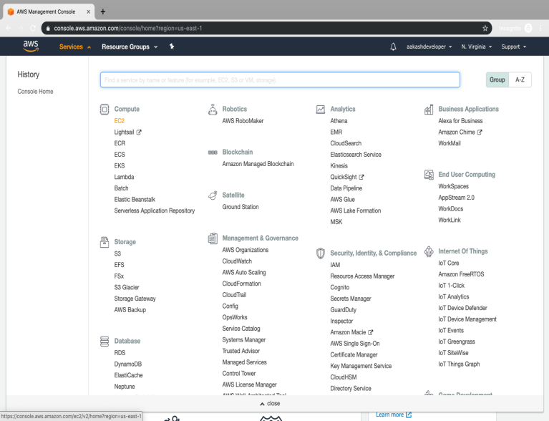

* Click on launch instance to run any instance

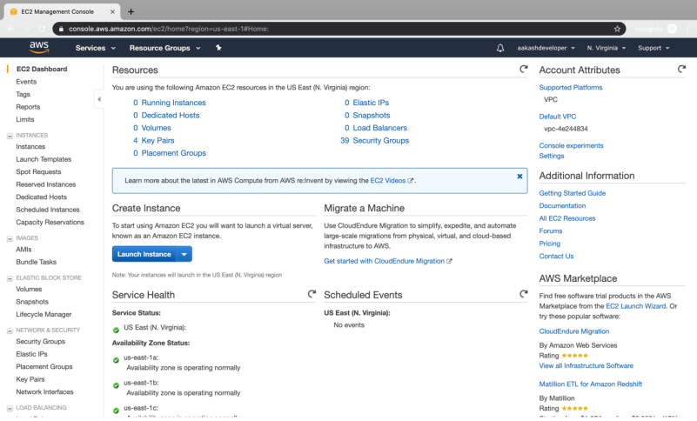

* Select the AMI

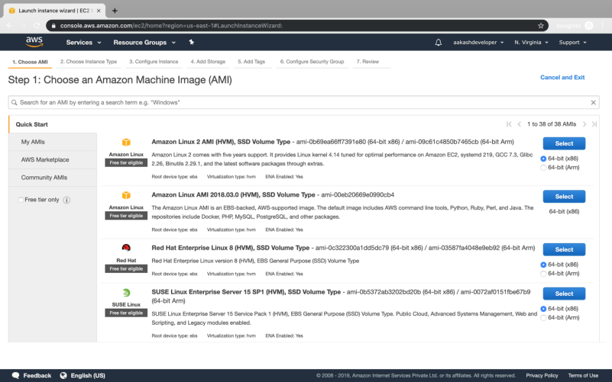

* Select t2.micro as the instance type

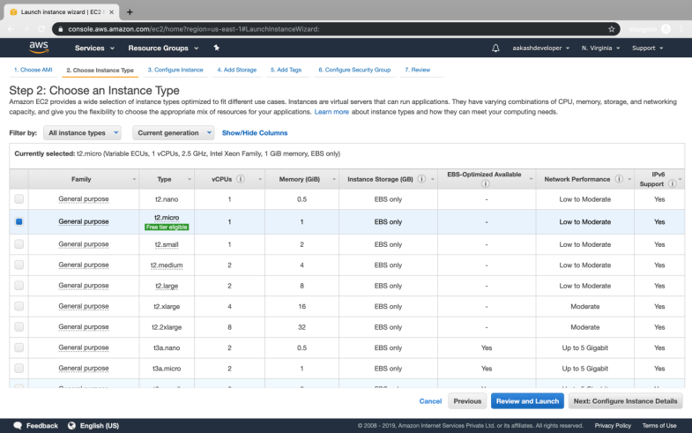

* Specify the number of instances, networks, placement groups, and IAM roles and click *Next*

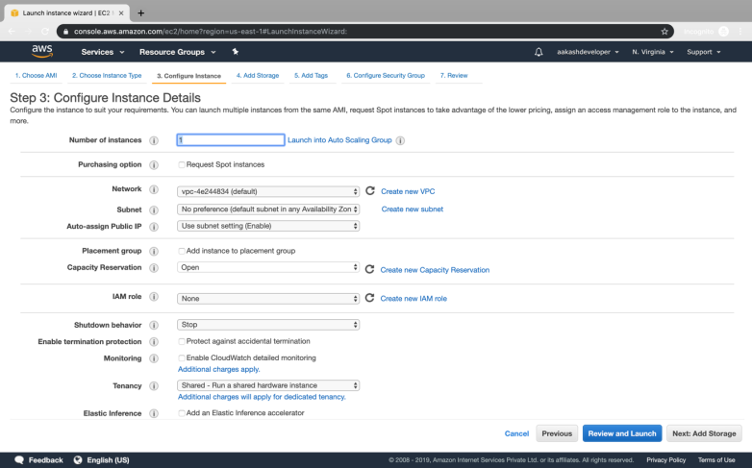

* There is one volume attached to the instance by default
* In Linux, the default volume attached is 8 GB
* You can add more volume if required

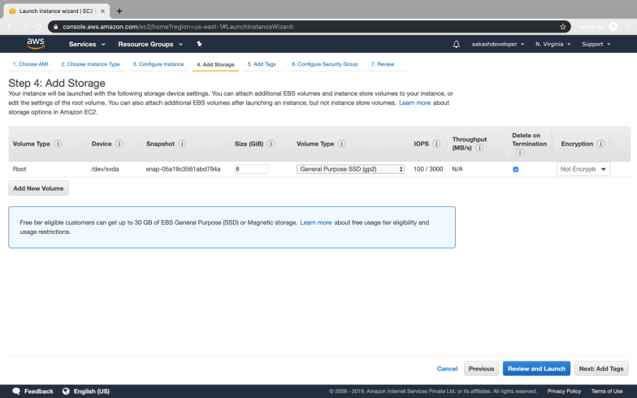

* You can add a key-value pair to the instance

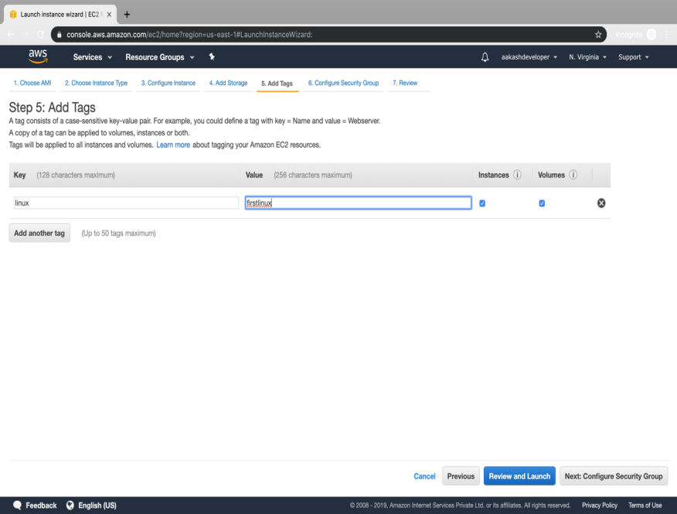

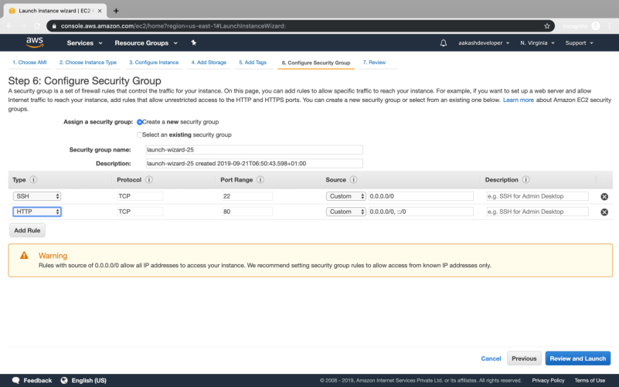

* Attach the three policy groups depending on the type of access required

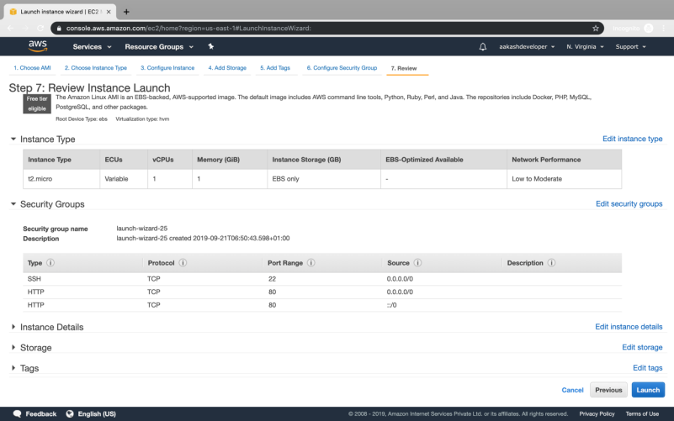

* Select an existing key-value pair to launch the instance

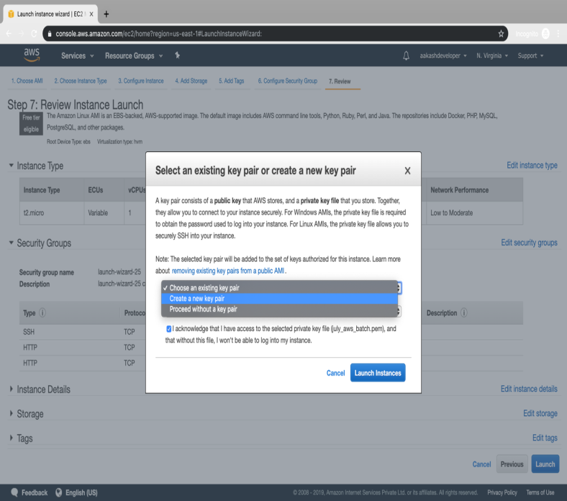

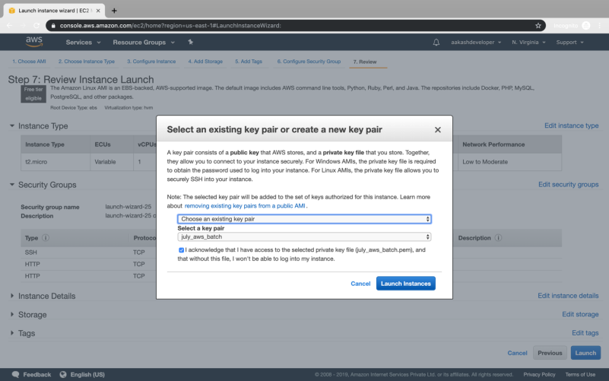

* The instance is ready to use

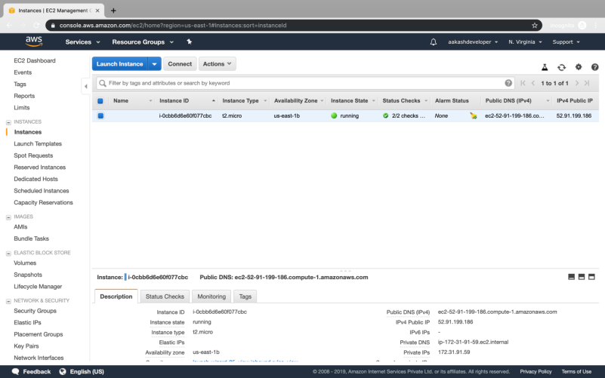

* Click on *Connect* on EC2 dashboard
* Run the ssh command provided

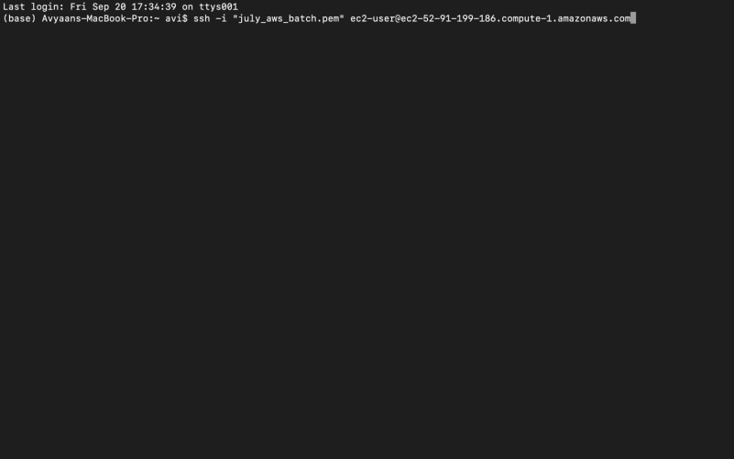

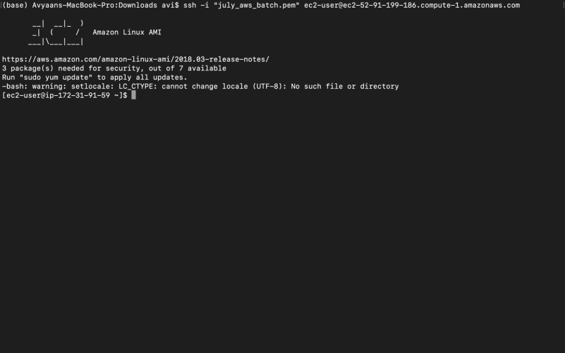

**Step 3.1.2:** Connecting to an EC2 instance

* Run the following command to launch a website over EC2:

yum install httpd -y

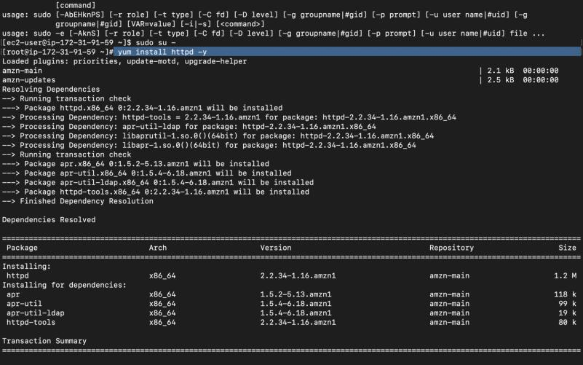

* Create Bucket to store jar file:

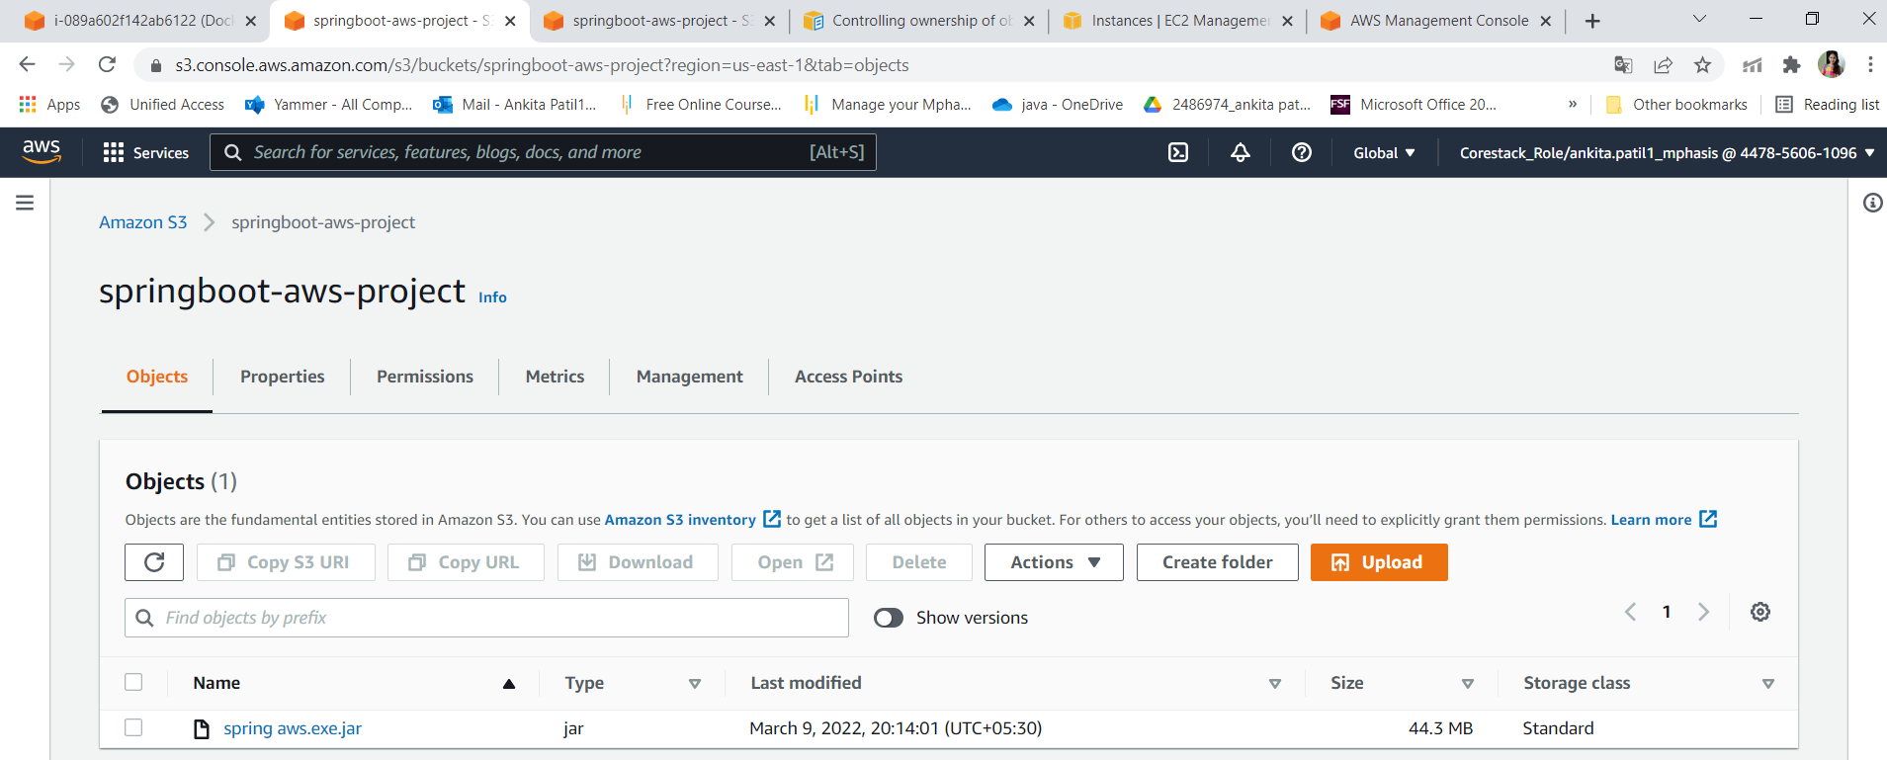

* Write springboot program:

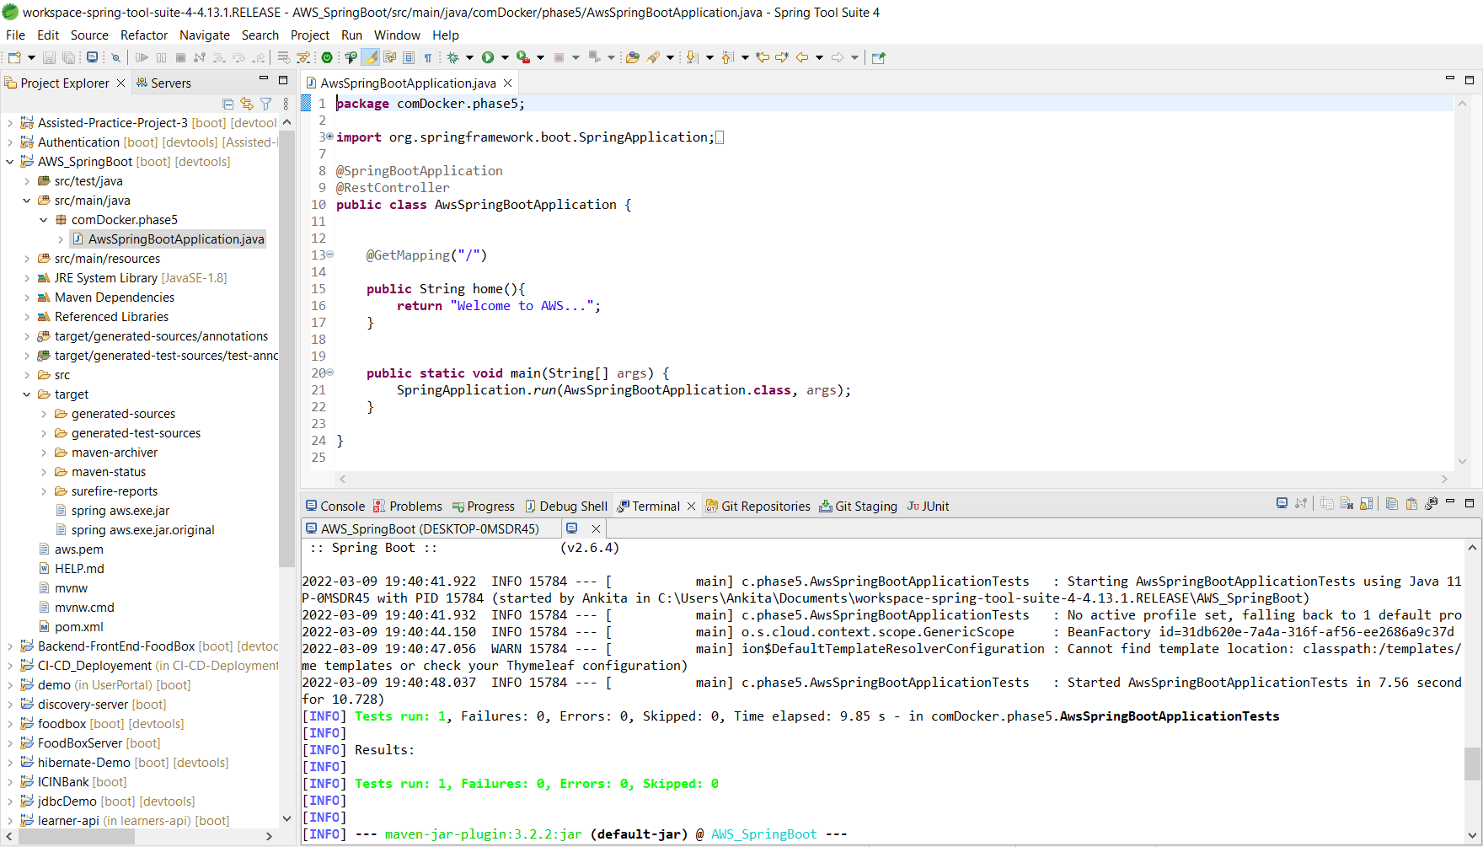

* **Run the program from cloud using bucket files:**

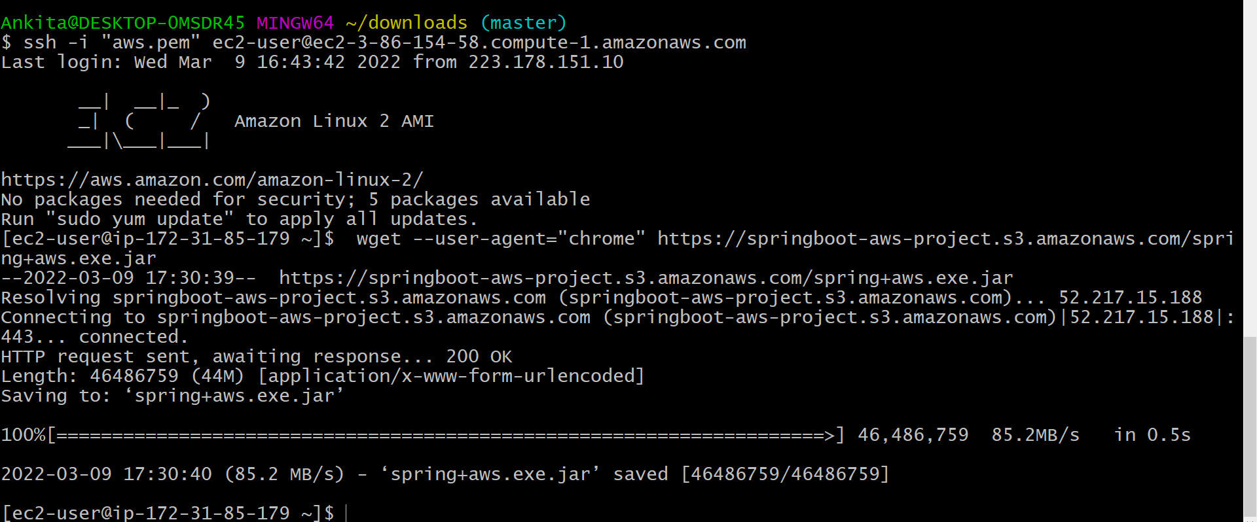

* **Run java program on server through cloud:**

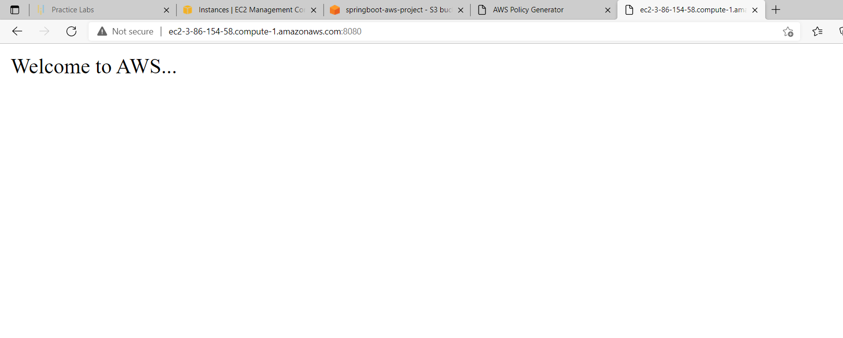

**Step 3.1.3:** Pushing the code to your GitHub repositories

* Open your command prompt and navigate to the folder where you have created your files.

**cd <folder path>**

* Initialize your repository using the following command:

**git init**

* Add all the files to your git repository using the following command:

**git add .**

* Commit the changes using the following command:

**git commit . -m “Changes have been committed.”**

* Push the files to the folder you initially created using the following command:

**git push -u origin master**